Assignment No.

* Creating EMPLOYEES table

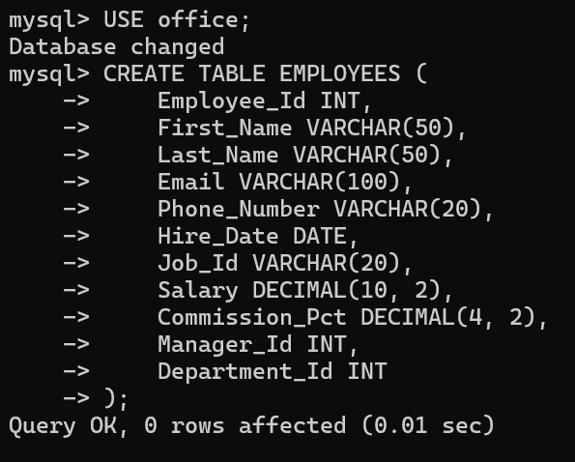

* Inserting Values

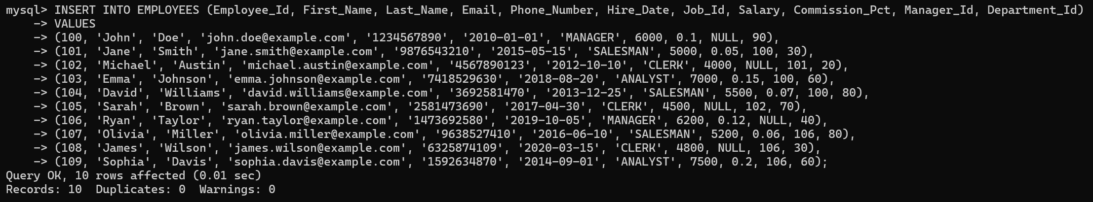

1. Find out the employee id, names, salaries of all the employees.

Sol.:

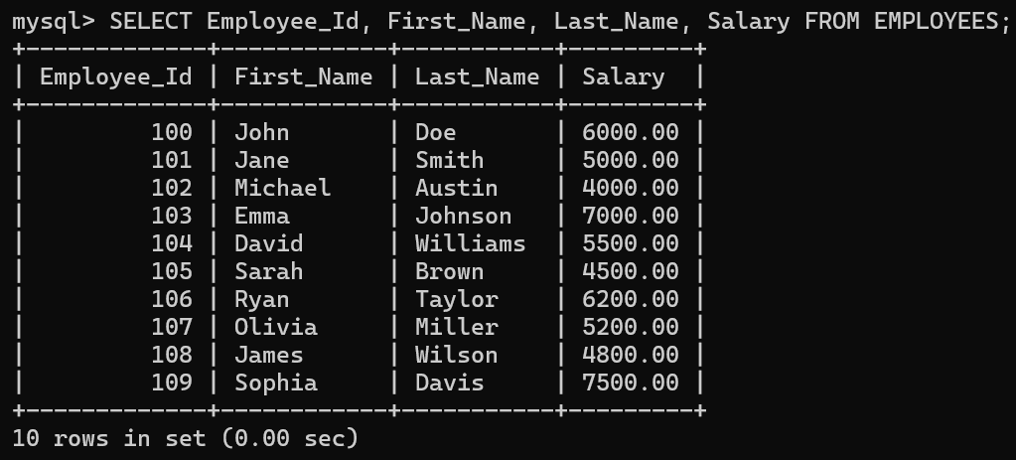

1. List out the employees who works under manager 100.

Sol.:

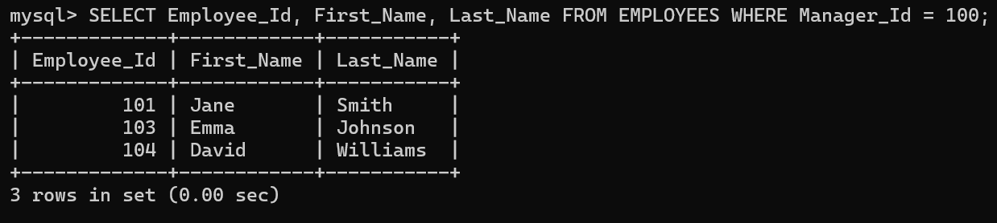

1. Find the names of the employees who have a salary greater than or equal to 4800.

Sol.:

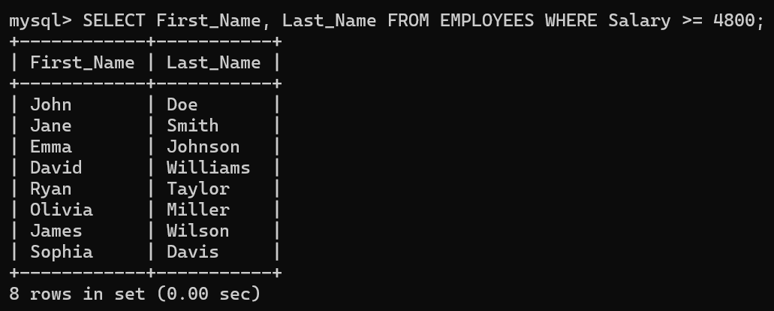

1. List out the employees whose last name is ‘AUSTIN’.

Sol.:



1. Find the names of the employees who works in departments 60,70 and 80.

Sol.:

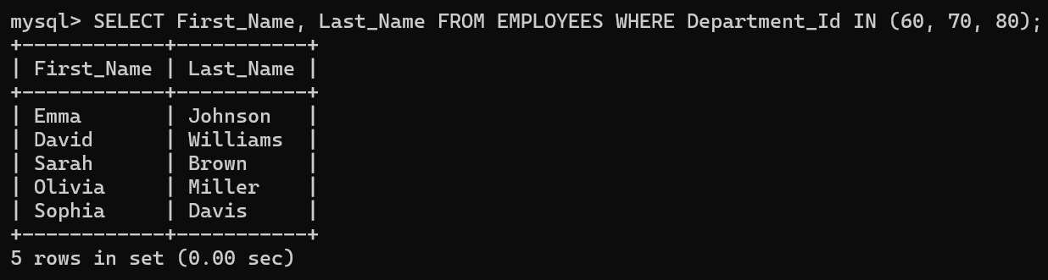

1. Display the unique Manager_Id.

Sol.:

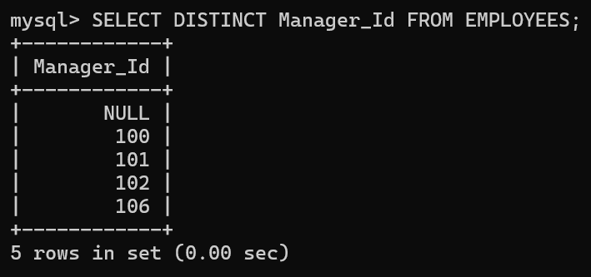

1. Delete the record of the Employee id 102.

Sol.:

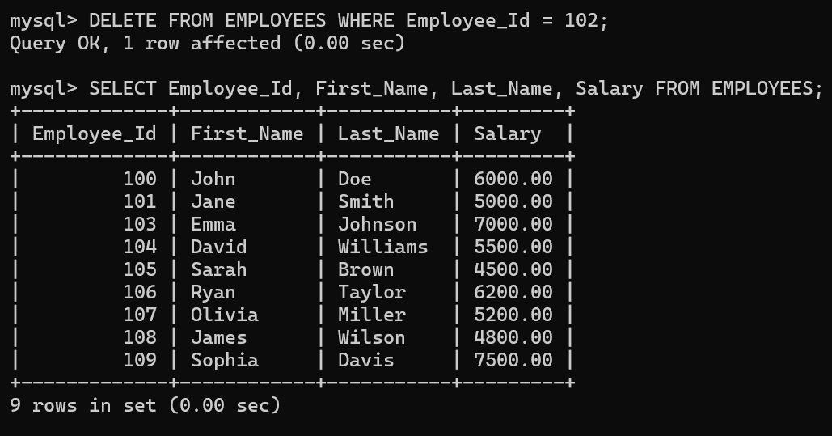

1. Change the salary of the employee “John” to 50000.

Sol.:

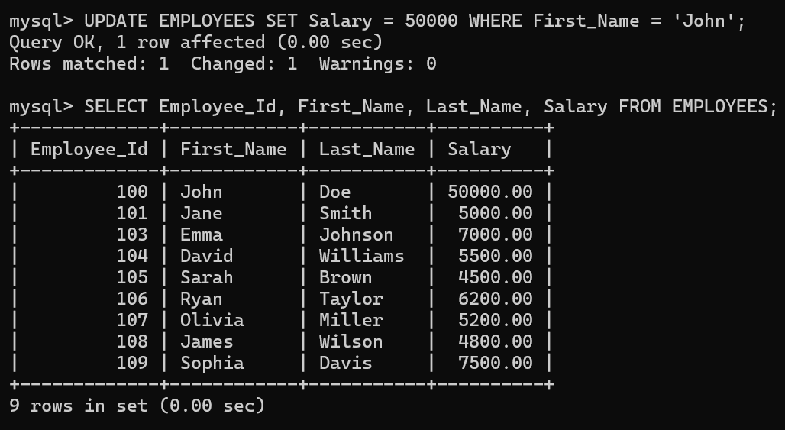

1. List the employees who has joined after 1 st Jan 2010.

Sol.:

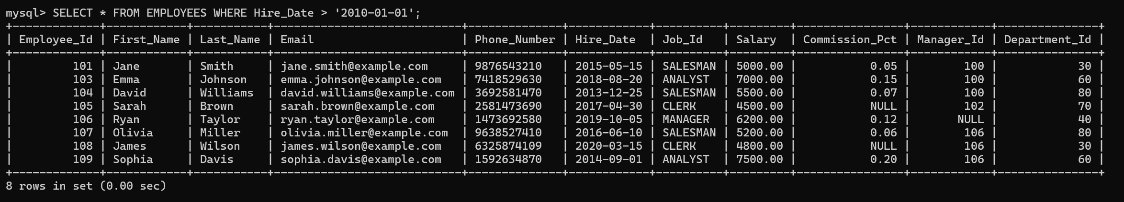

1. Display the names of the employees whose first name starts with “A”.

Sol.:

